Google Analytics

Added May 05, 2018.

1. To register an account, please follow the link <https://www.google.ru/>.

2. In the window that opens, click on the button “Sign in”.

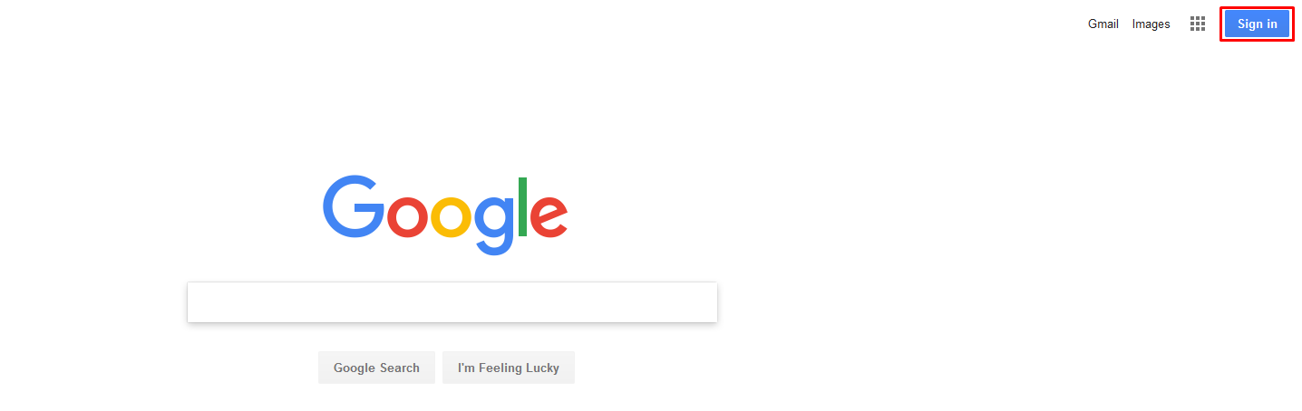

3. Then click on the link “Create account”.

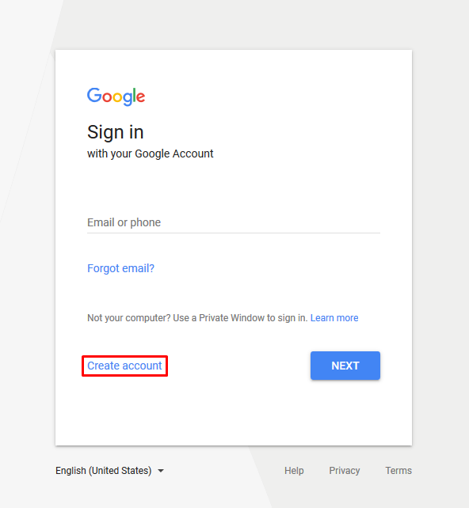

4. Fill in the required data and click on "Next".

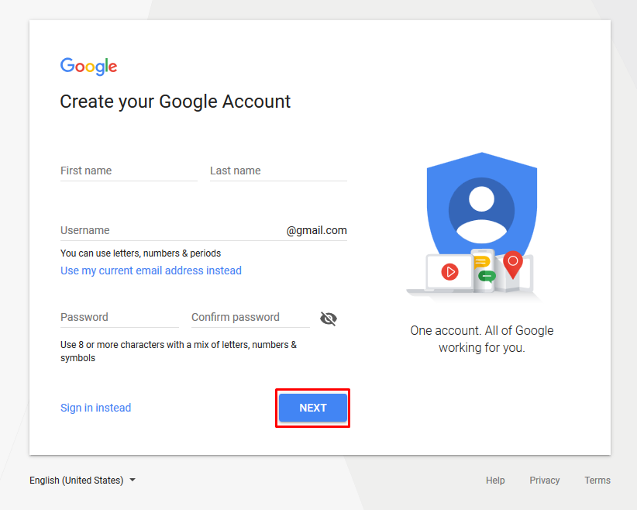

5. In the next window, specify the phone number, date of birth, gender and click on "Next".

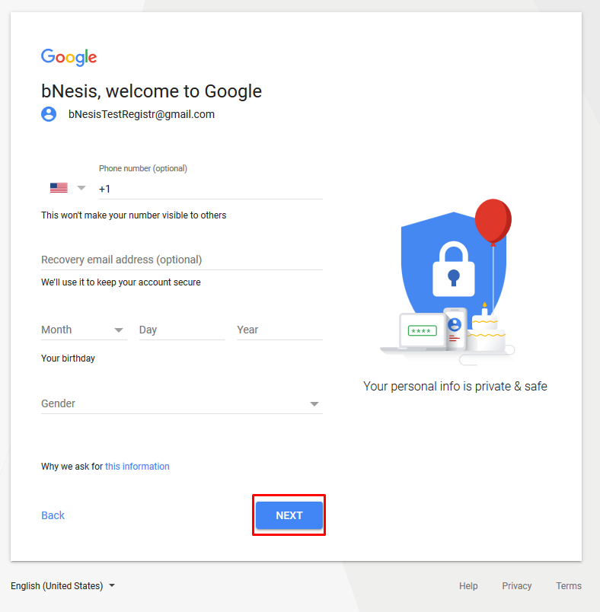

6. It is necessary to verify your phone number, click on the "Send" button.

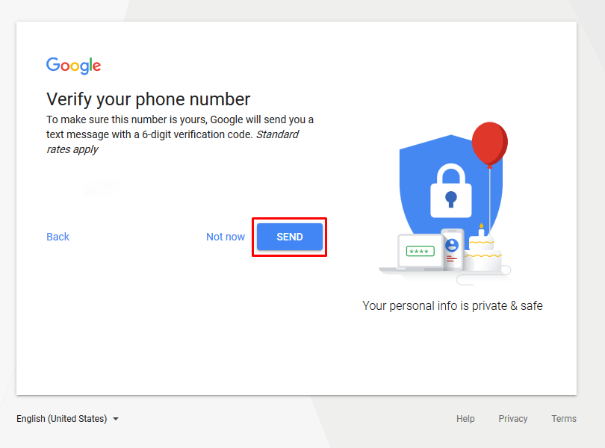

7. Specify the code that came in the SMS, and click on the "Verify".

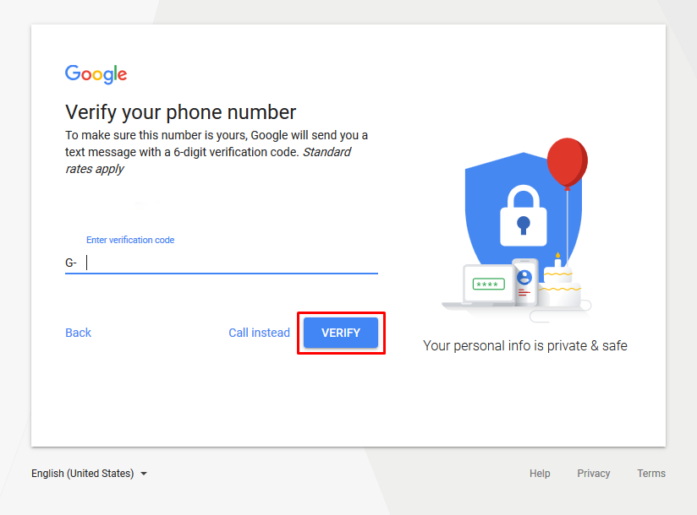

8. Read the license agreement and click on "I agree".

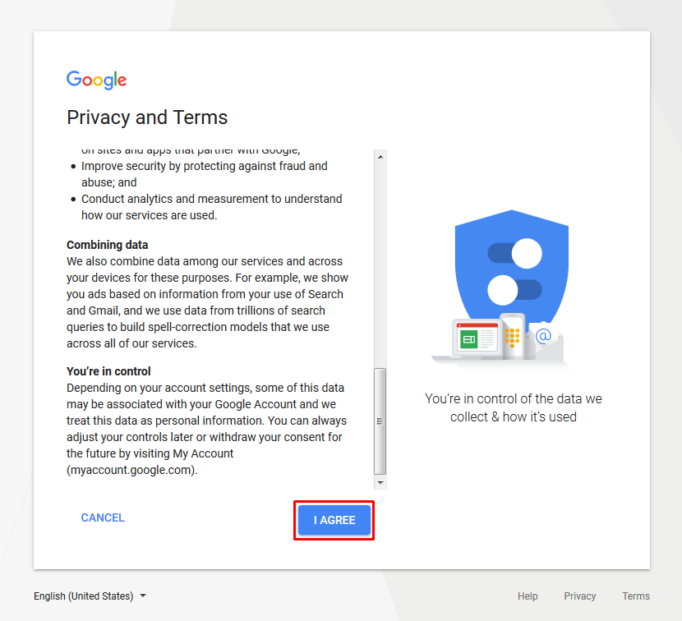

9. You signed up for Google.

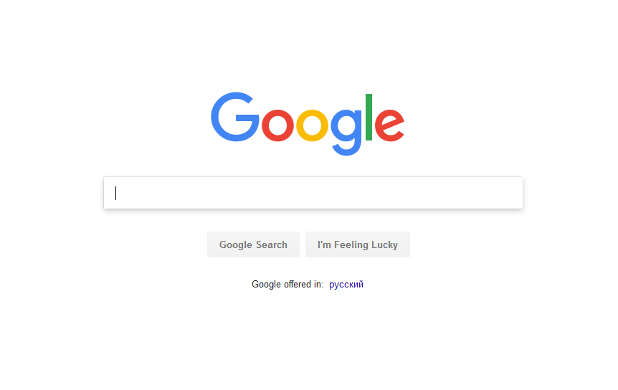

10. To register the application, follow the link  
 <https://console.developers.google.com/>.

11. Click on "Create Project".

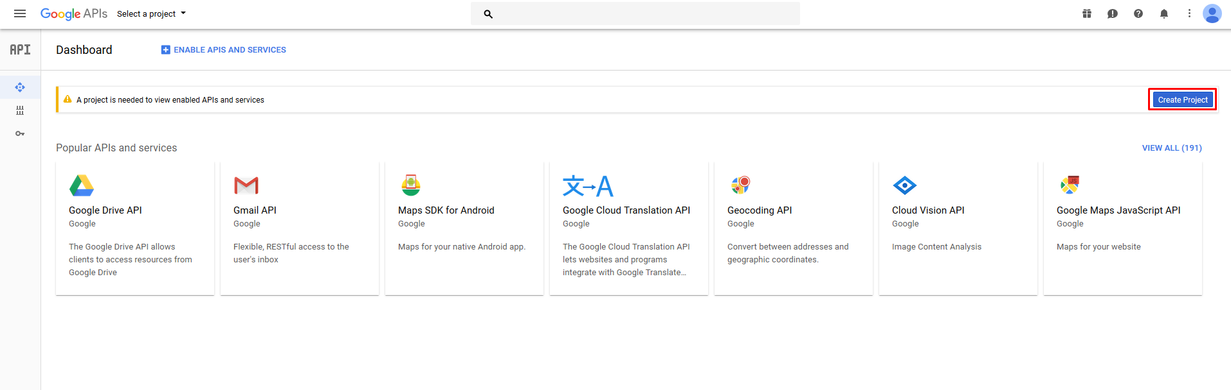

12. In the next window click on "Create".

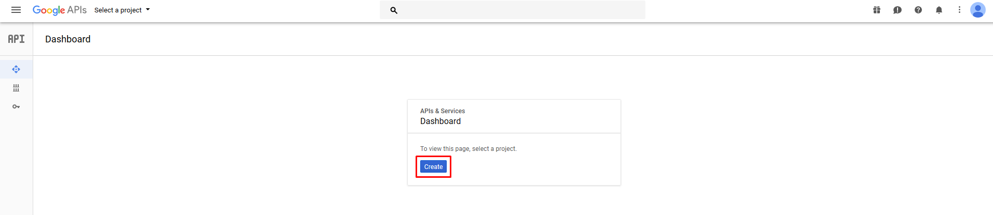

13. Specify the name of the project and click on "Create".

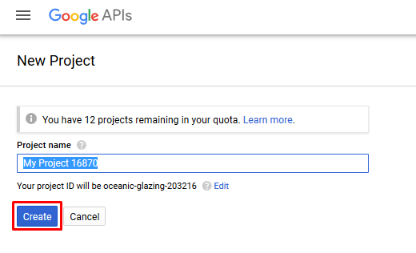

14. Go to the category "Library".

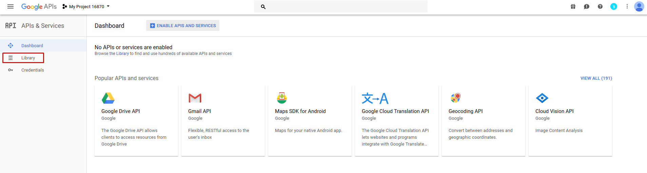

15. Here you need to select the service you are interested in.

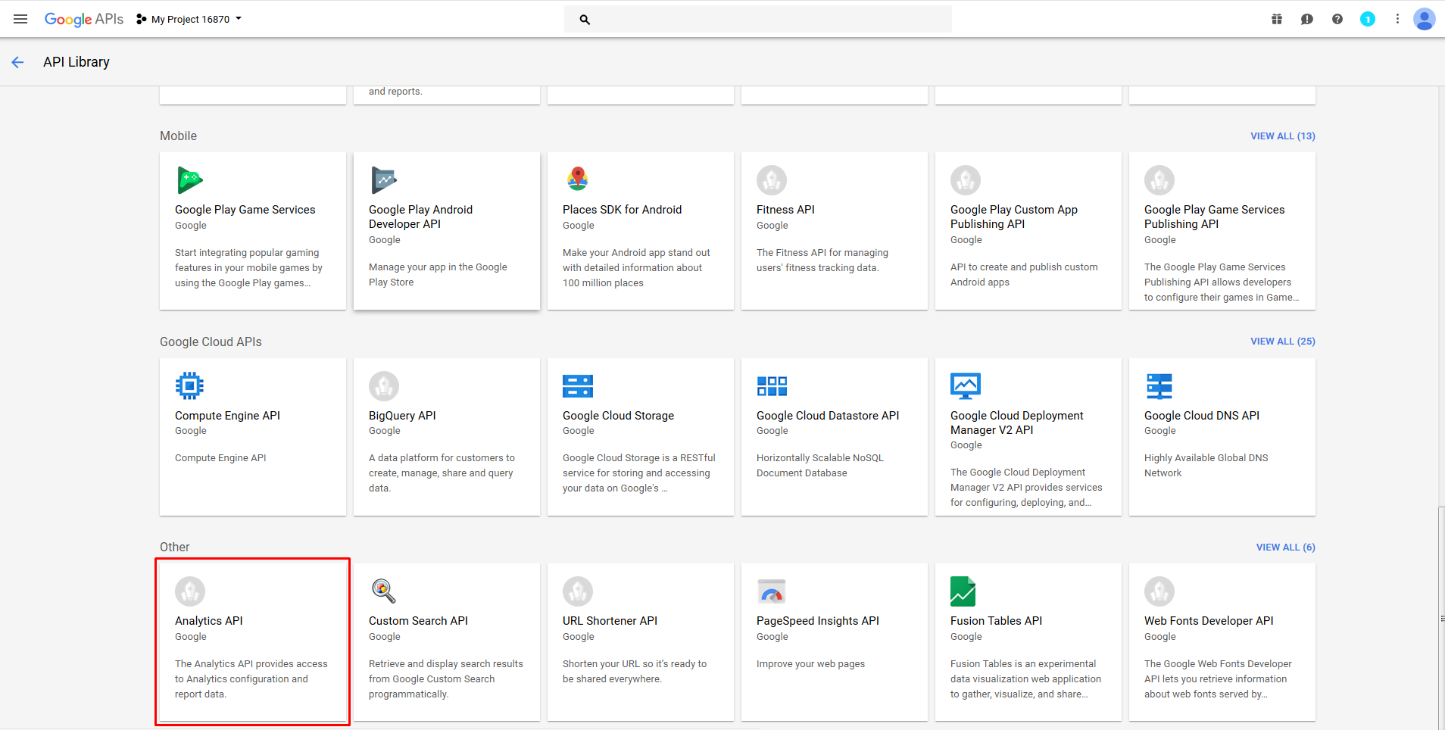

16. On the next page, connect the API by clicking on the "Enable".

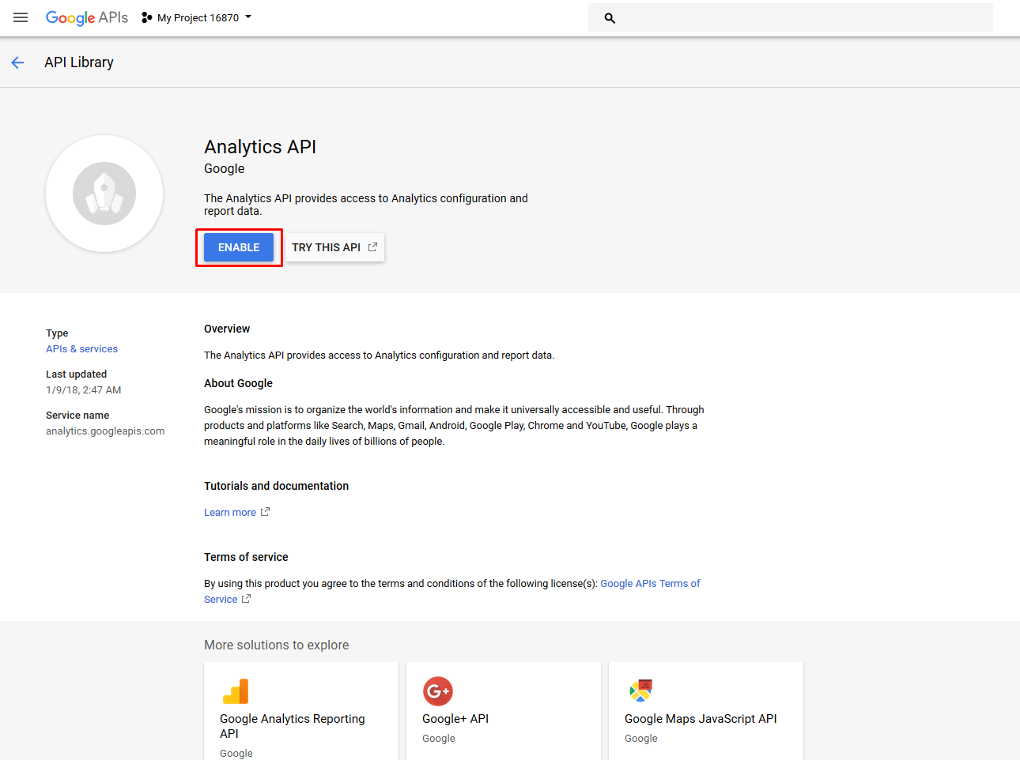

17. Next you will be redirected to the settings window of the selected service, click on the "Create credentials" button.

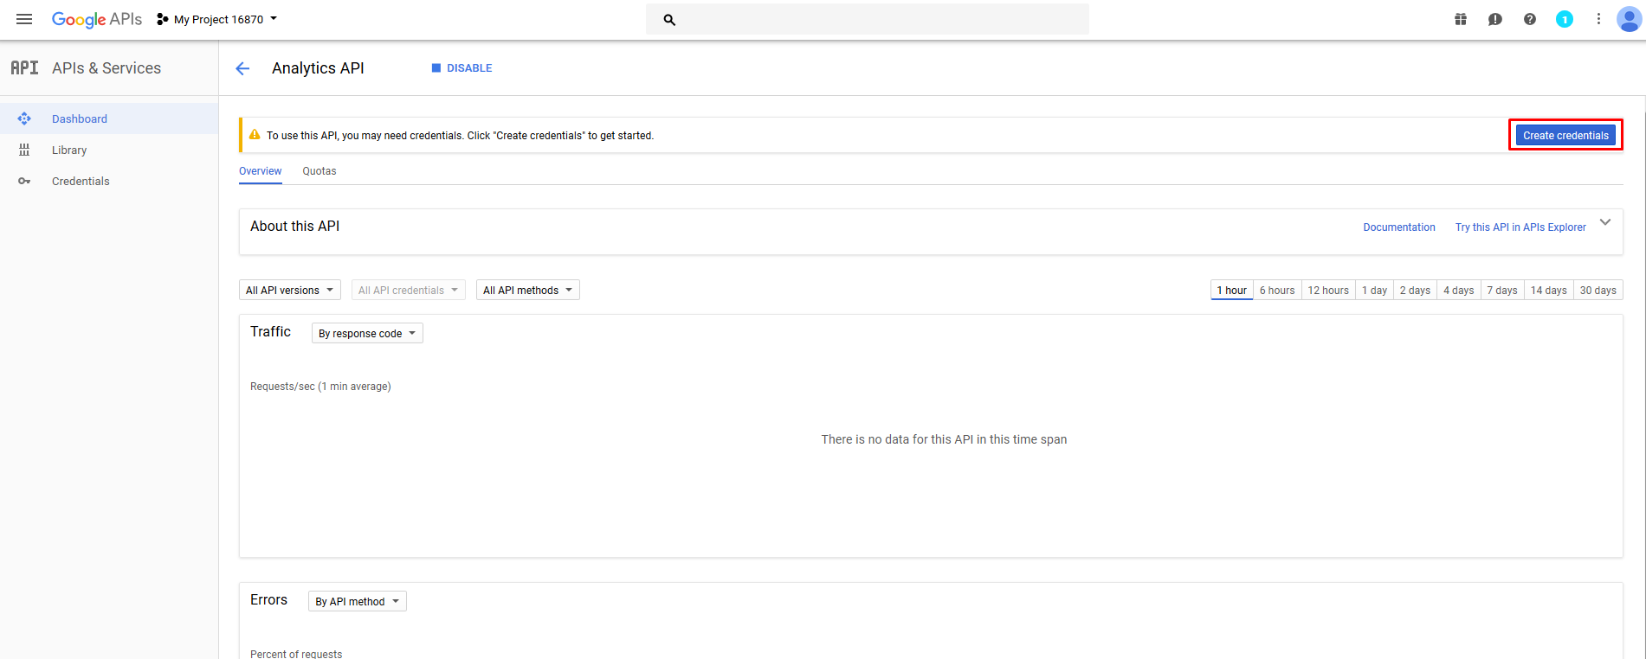

18. Make the initial settings and click on "What credentials do i need?"

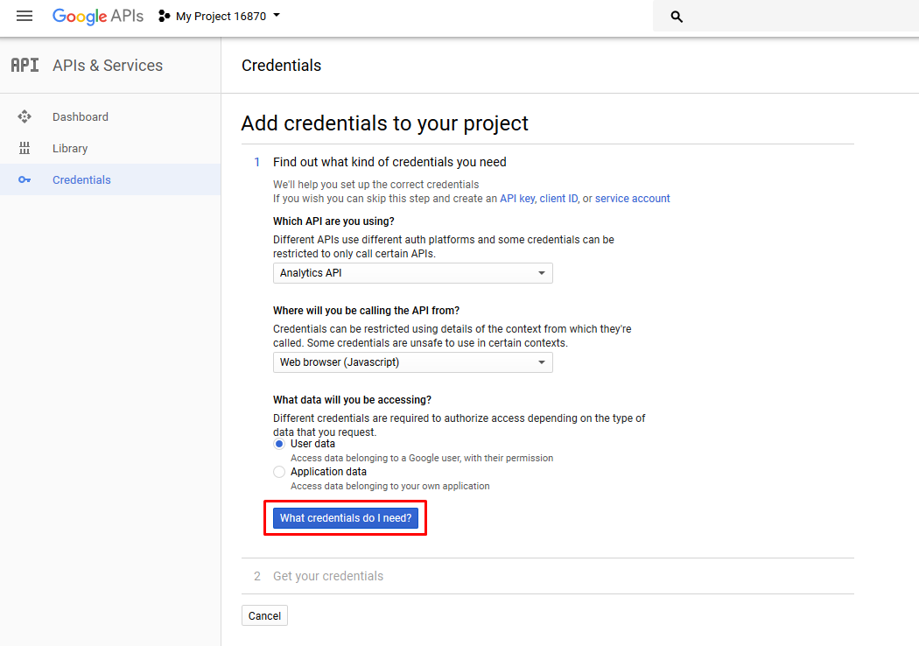

19. In the next window, specify the redirect URL and click on the "Create OAuth client ID".

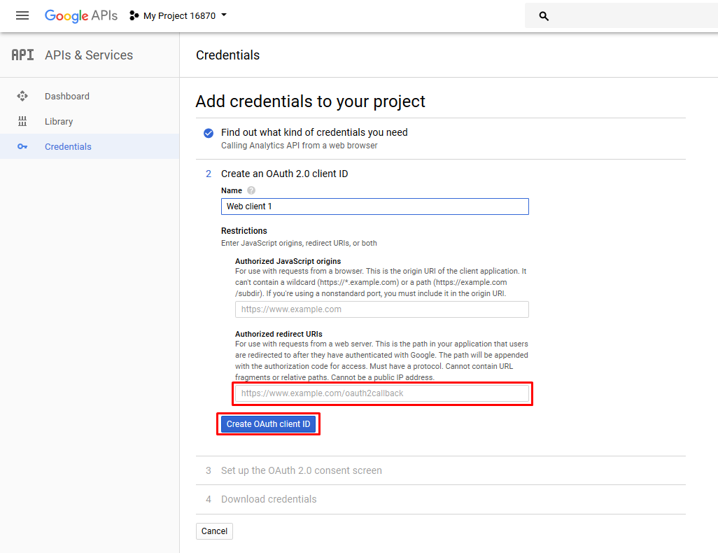

20. In the next window, specify "Product name shown to users" and click on "Continue".

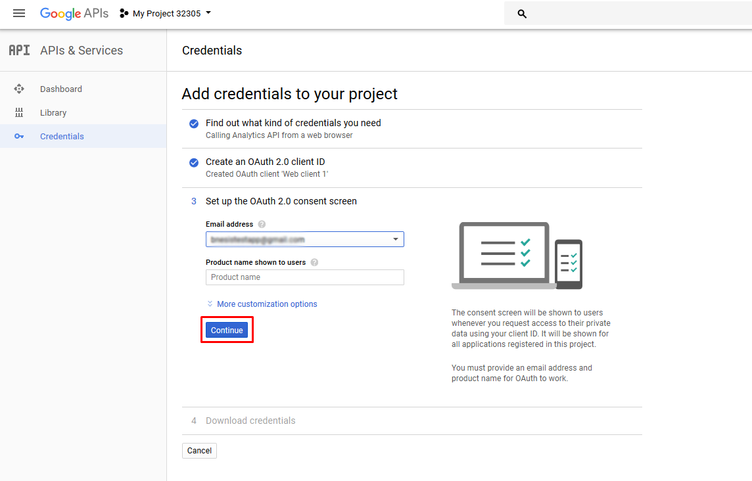

21. Now you can download the required Client ID and Client Secret by clicking on the "Download" button. After that, click on the "Done" button.

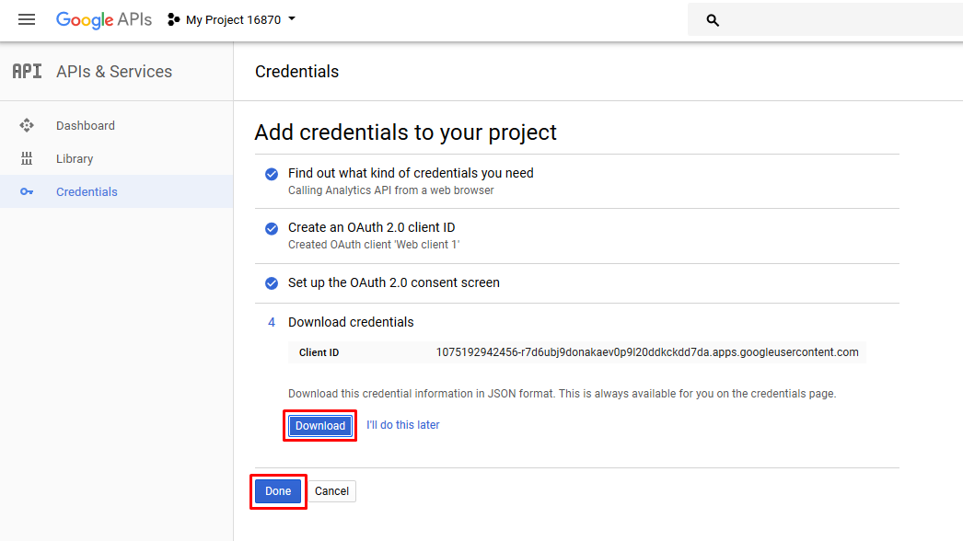

22. Settings are made.

